**Abstract of Hong Kong Protests Analytics Project**

The 2019 Hong Kong Protests sparked off by the Extradition Law Amendment Bill introduced by the Special Administrative Region (SAR) government in March this year. This issue has gone viral online and led to an increasing number of protestors and a series of planned demonstrations across the island. Due to the newsworthy and contentious nature of the issue, a detailed analysis integrating social science research methodology and data analytics methods will benefit many people in the society, ranging from news media agency to sociologist researching on political issues.

We have scraped data from social media platforms like Twitter and Reddit using real time listener on AWS cloud to maximise the amount of data collected. After data manipulation and data cleansing, we have generated data sets to perform network analysis and text & sentiment analysis.

For network analysis, we have visualised the interactions between twitter users using Gephi and calculated the network measures at both macro and micro level. At the micro level, we are able to identify different types of influencers in the network based on the centrality measures. At the macro level, we are able to observe the changes of network structure and characteristics over time.

Our text analysis consists of sentiment analysis and topic extractions. For sentiment analysis, we have used vader polarity score to observe overall sentiment of twitter users in different regions over time. To further analyse users’ sentiment towards each topic, we have first extracted a list popular topics, and under each topic, we have conducted sentiment analysis as well as common words related to the topic which can be representative of a user’s opinion.

The consolidated findings were visualised them into a Tableau dashboard. The dashboard displays location-specific sentiment scores and can display the information filtered by time. Together with the network graphs and word cloud generated, these visualisation allows individuals who are interested in the issue to gain a better understanding.

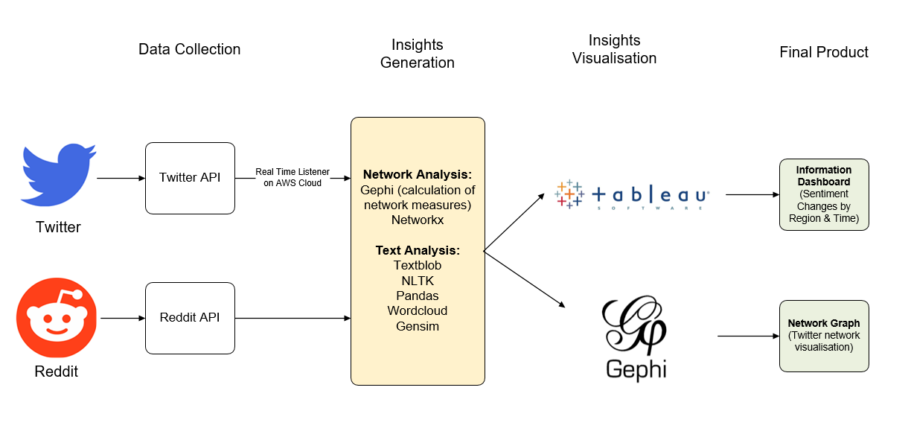

*Data Analysis Flow Diagram*

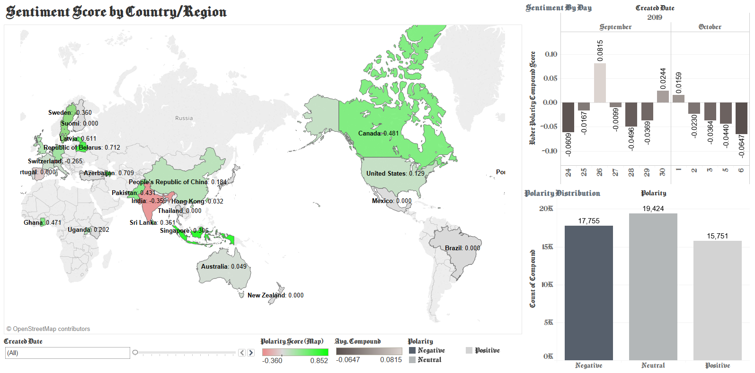

*Tableau Dashboard displaying Sentiment Analysis*

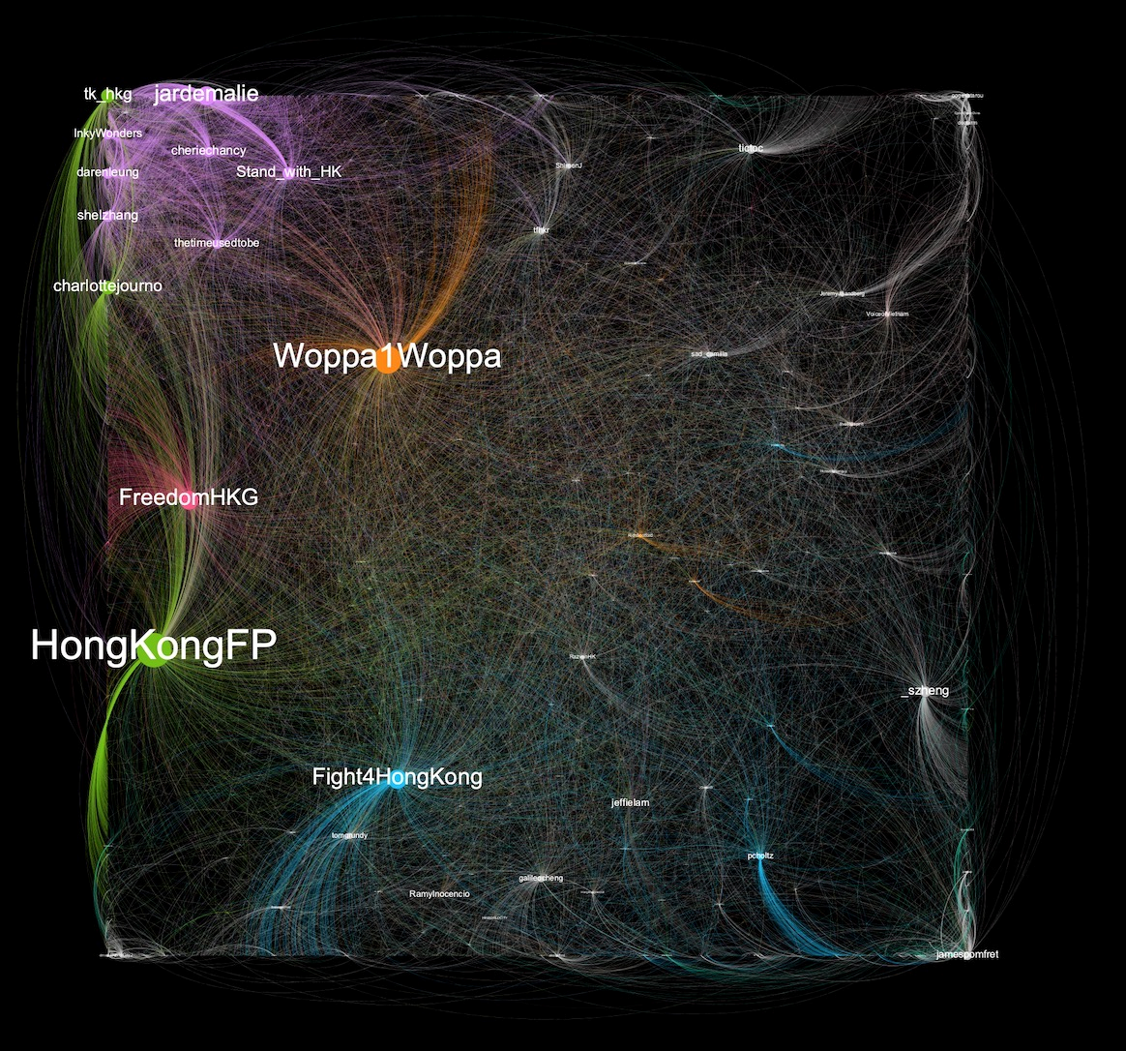

*Network Graph of Twitter Data retrieved on 30 Sep 2019 (1 day prior to the National Day of PRC), generated by Gephi, displaying twitter users with high degree centrality (coloured by different communities)*

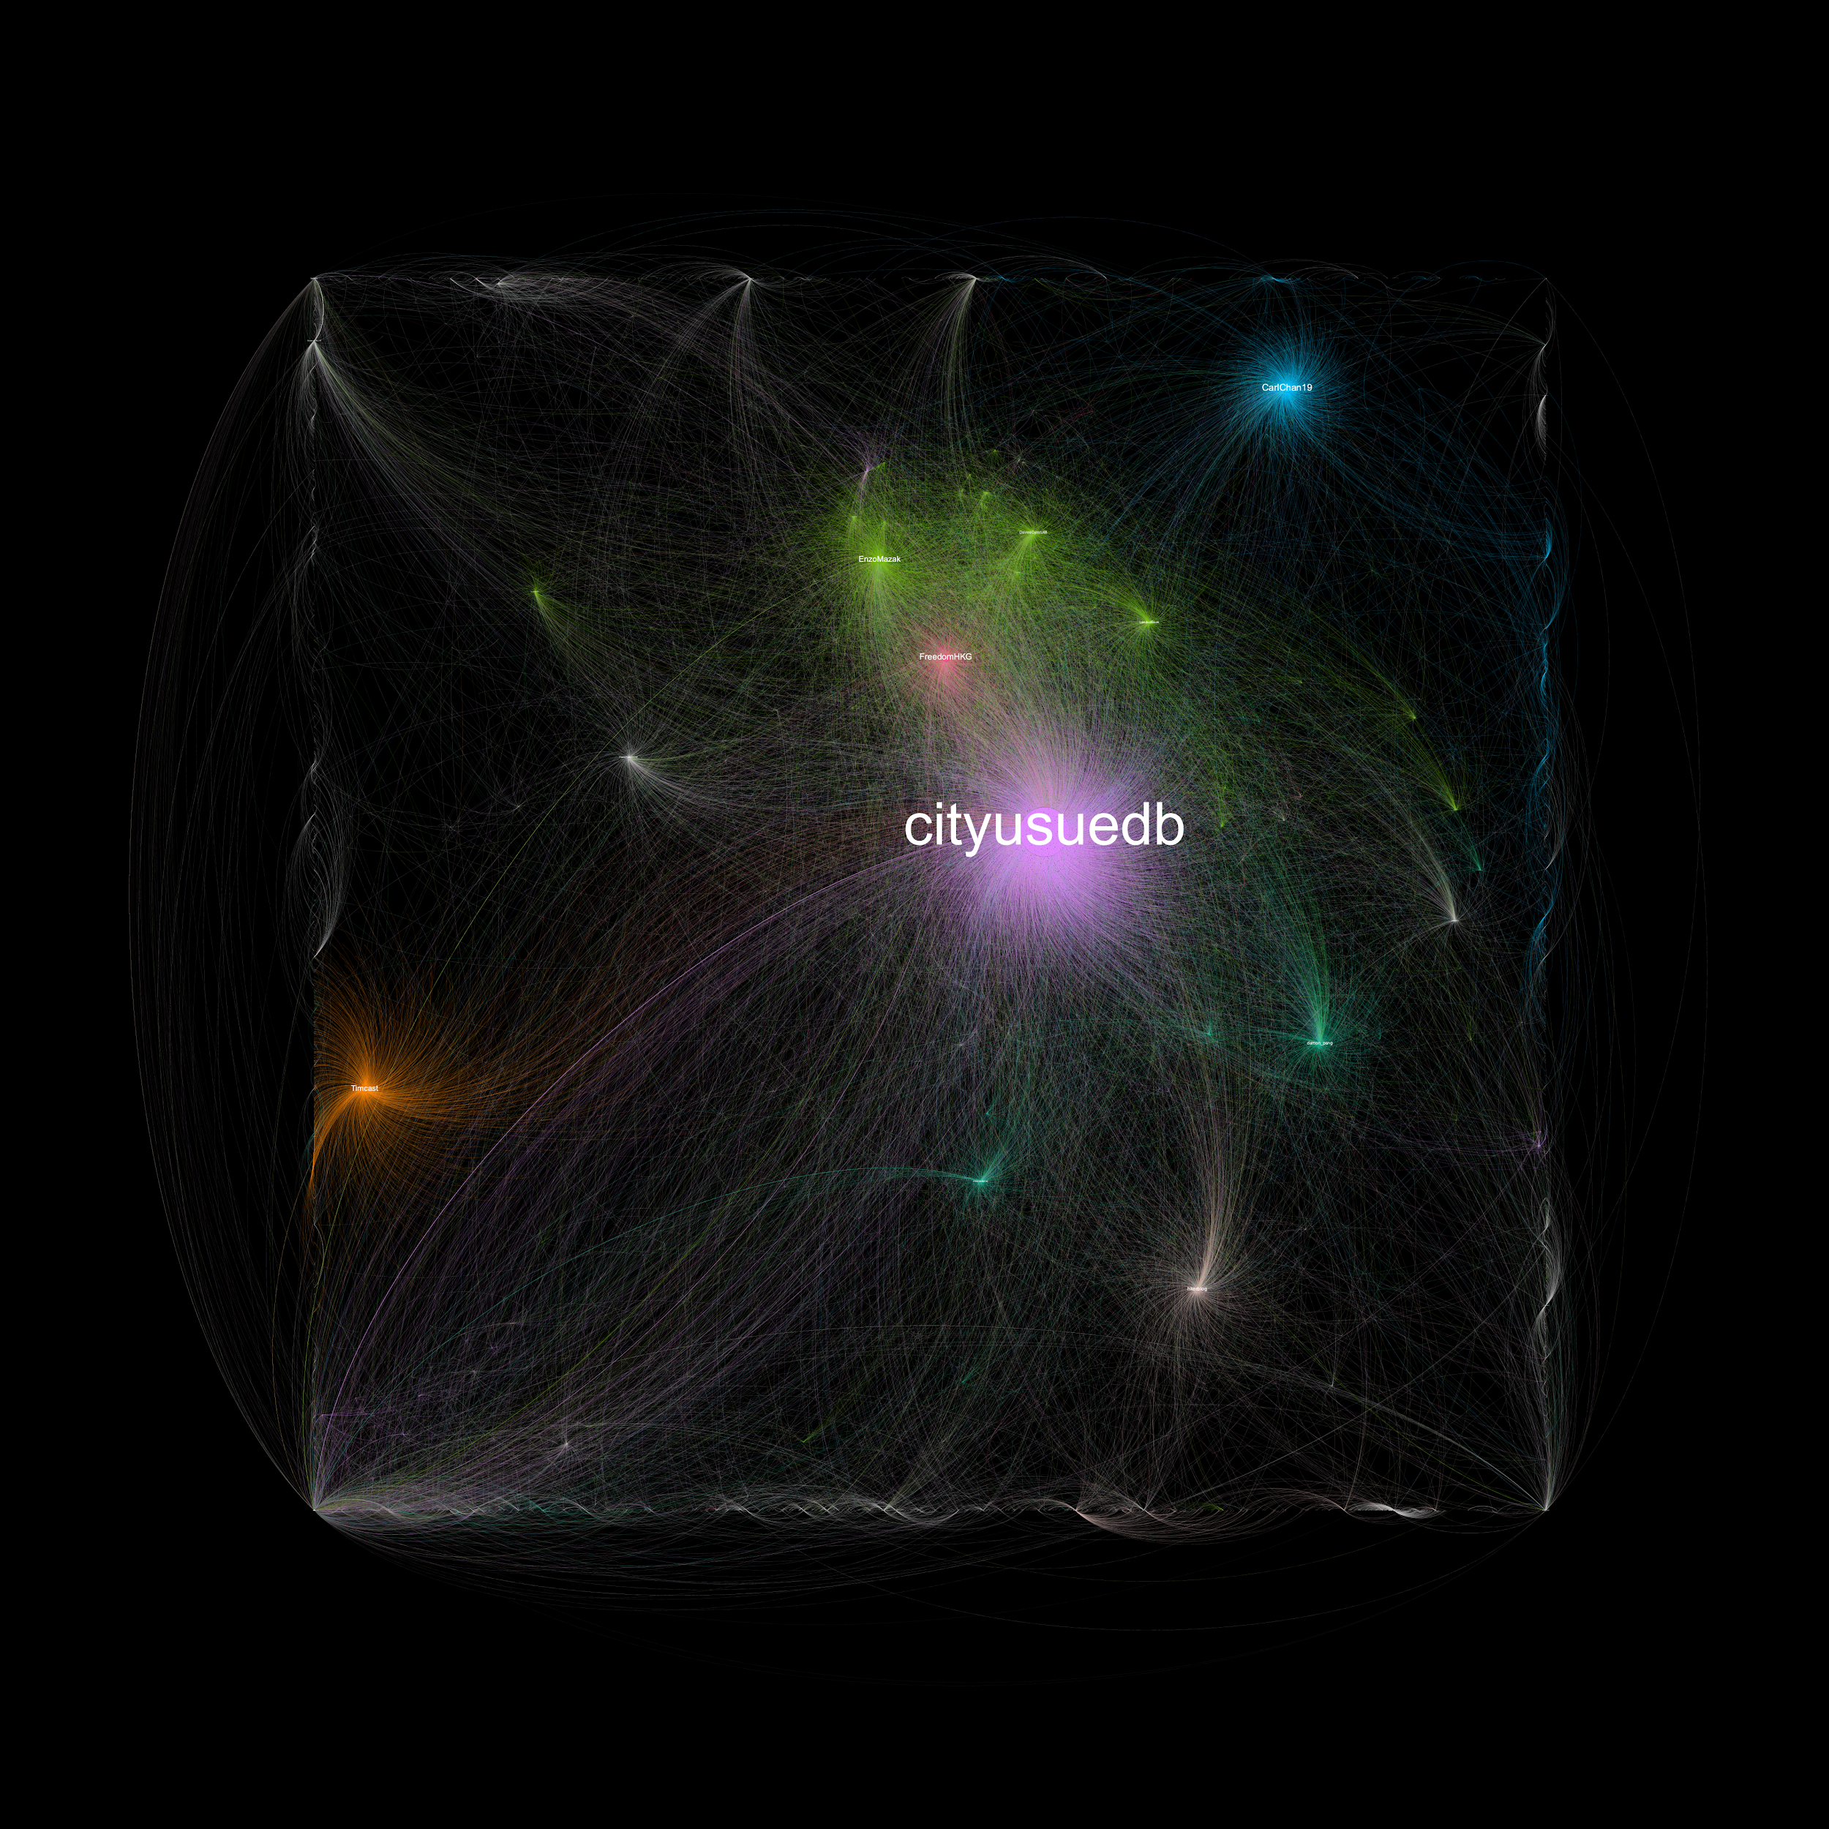

*Network Graph of Twitter Data retrieved on 1 Oct 2019, generated by Gephi*

*(Massive changes in the network structure prior to and after the National Day of PRC)*

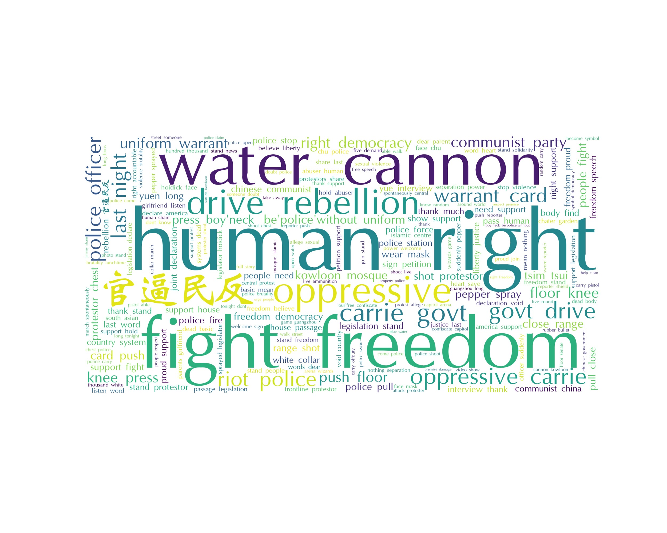

*Word Cloud generated from sampled tweets from 24 September to 25 Oct*